ALL PROBLEM STATEMENT :-

Problem Statement: (ALOK)
In many underprivileged communities, access to quality healthcare and medical guidance is limited due to financial constraints, lack of awareness, and insufficient healthcare infrastructure. As a result, people often remain unaware of preventive measures, early symptoms, and proper treatment options for their health issues. Meanwhile, many doctors are willing to volunteer their time and expertise but lack a structured platform to connect with those in need, especially during their off-duty days. This gap leads to a missed opportunity where valuable medical knowledge and guidance could significantly improve the health outcomes of disadvantaged groups

Problem Statement: (ALOK)
Urban areas often face recurring civic issues such as road potholes, garbage accumulation, traffic congestion, and waterlogging. These problems not only cause inconvenience to citizens but also lead to health risks, accidents, and damage to infrastructure. Although authorities are responsible for timely maintenance, the absence of a quick and transparent reporting mechanism delays the resolution of such issues. Citizens who encounter these problems daily lack an accessible platform to report them effectively with location details. Consequently, civic problems persist longer than necessary, leading to dissatisfaction and reduced quality of life in the community.

Problem Statement: (BHUMIKA)
{
Women’s safety is a growing concern, with incidents of harassment, stalking, and violence still prevalent in public and digital spaces. While there are safety apps and helplines available, they are often limited to individual use, lack real-time community involvement, and sometimes fail to provide immediate help during emergencies.

A key challenge is that women in distress may not always be able to contact authorities or family instantly. At the same time, bystanders or nearby individuals who want to help often lack an anonymous and safe way to intervene.

This highlights the need for a community-driven platform where:

Women can raise an instant SOS alert in case of emergencies.

Nearby verified users (volunteers, students, citizens) are notified and can provide immediate, anonymous help (e.g., escorting, calling police, guiding to safe areas).

Users can report unsafe locations or incidents anonymously, helping to build a crowd-sourced safety map.

The platform ensures privacy and anonymity so helpers and victims both feel secure.

By enabling both women and community members to participate, the project aims to create a technology-driven safety ecosystem that empowers women and encourages collective responsibility for safer public spaces.
}

Problem Statement (Tejaswini)
{

AI + Human Mental Health & Consulting Support Platform

Mental health challenges such as stress, anxiety, depression, and burnout are rising at
unprecedented rates, affecting students, working professionals, and individuals across all walks
of life. Despite growing awareness, access to effective support remains limited due to several
barriers: the stigma of seeking therapy, shortage of qualified professionals, high treatment costs,
and the lack of immediate assistance in times of crisis. While AI-driven chatbots have recently
emerged to provide round-the-clock availability, they are often impersonal, unable to fully
replace the empathy, expertise, and contextual understanding that human interaction offers. On
the other hand, relying exclusively on professional therapy creates challenges of affordability,
waiting times, and limited scalability.
To address these gaps, this project proposes a hybrid AI + Human Support Platform that
integrates the strengths of technology with human compassion. The system features an
AI-powered chatbot capable of natural language processing and sentiment analysis to
provide instant, stigma-free emotional support, relaxation techniques, and mood tracking.
Based on severity detection, the chatbot intelligently escalates cases to either community
volunteers (empathetic listeners who offer companionship and encouragement) or certified
consultants and therapists (professionals such as psychiatrists, psychologists, life coaches,
and career counselors). A personalized wellness hub further empowers users with resources
like guided meditations, self-care exercises, progress tracking, and expert content.
By combining AI scalability with human empathy and expertise, the platform not only
improves access to affordable mental health care but also expands its scope into personal growth
and life consulting. It ensures privacy, confidentiality, and cultural sensitivity, while also
offering an SOS emergency system for high-risk cases. This approach creates a
comprehensive, accessible, and sustainable mental wellness ecosystem, capable of
transforming how individuals seek help and manage their emotional well-being.

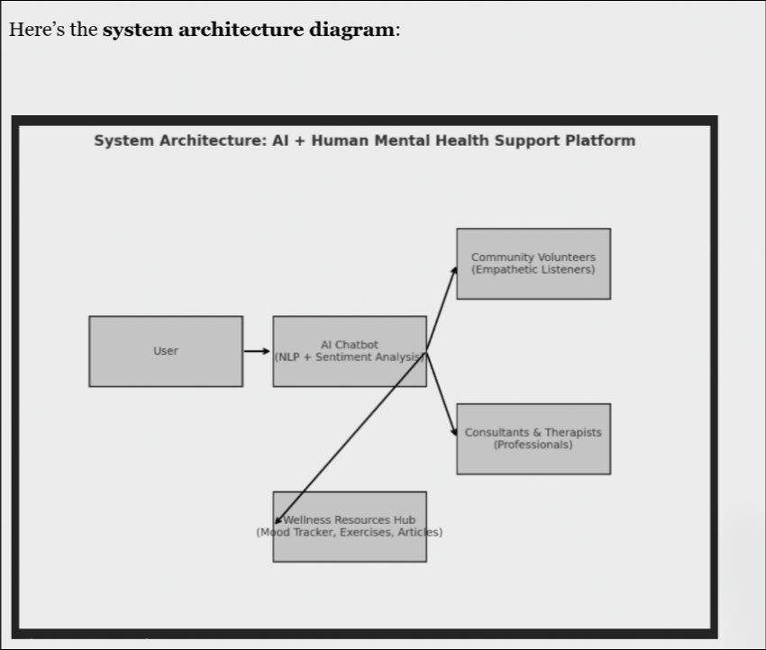

Here’s the system architecture diagram:
It shows how a user first interacts with the AI chatbot, which then decides whether to:
● provide self-help via resources,
● connect to community volunteers, or
● escalate to consultants/therapists for professional support.

}

COMBINING ALL PROBLEM STATEMENT:-

Main Problem Statement
In large, rapidly urbanizing cities like Delhi, the fundamental challenge to urban life is a critical disconnect between citizens and the very systems designed to support them. This gap is felt acutely in the daily lives of its people: from the pervasive fear women experience on poorly-lit streets, where a real-time link to community helpers in an emergency is non-existent, to the civic frustration of watching garbage piles and road potholes persist as complaints disappear into the opaque bureaucracy of the MCD. This same fragmentation extends to healthcare, denying underprivileged families access to vital medical guidance from volunteer doctors and creating barriers to basic well-being. Ultimately, this systemic failure in communication and connection leaves citizens feeling disempowered, unsafe, and unheard, preventing Delhi from becoming the truly sustainable, inclusive, and resilient community it aspires to be.

The Solution:
The solution is a unified, AI-powered, full-stack platform. It is designed to be the single digital bridge that closes the critical disconnect between the citizens of Delhi and the city's civic, safety, and health infrastructure. Instead of citizens navigating a fragmented and frustrating system, the app brings the system to them in an accessible, transparent, and empowering way.
The platform is built on four core pillars that directly address the key areas of disconnect:

1. Community-Powered Safety & Emergency SOS
To solve the problem of unsafe public spaces, the app transforms personal safety from an individual responsibility into a collective one. The Smart SOS feature not only alerts family and police but also notifies a network of nearby, background-verified community volunteers called "Suraksha Mitras." These volunteers can provide immediate, real-time assistance, creating a hyper-local safety net. A crowd-sourced safety map allows users to anonymously flag unsafe areas, turning citizen awareness into a dynamic, city-wide alert system for everyone.

2. Transparent Civic Reporting & Tracking (MCD Integration)
To fix the broken feedback loop with civic bodies, the app provides a quick, transparent, and effective reporting mechanism. A citizen can report a pothole, an overflowing garbage dump, or a broken streetlight in under a minute by uploading a geo-tagged photo. This complaint is logged directly with the MCD, and its status—from "Lodged" to "In Progress" and "Resolved"—is tracked transparently within the app. This creates accountability and turns civic frustration into actionable data.

3. Accessible Health & Wellness Connect
To address the inequitable access to healthcare, the app features a volunteer doctor platform. It securely connects citizens from underprivileged communities with verified doctors willing to provide free, first-level medical guidance through scheduled tele-consultations during their off-duty hours. This democratizes access to health advice, promotes preventive care, and removes the barriers of cost and travel for those who need it most.

4. Community Forum & Empowered Governance
To ensure citizens feel heard and empowered, the app includes a hyper-local community forum. Here, residents can post about local issues, and others can upvote them to signify urgency and importance. The platform aggregates this data from upvotes and community polls into actionable reports for local authorities (MCD, MLAs). This amplifies the collective voice of the community, turning individual grievances into powerful, data-driven insights that can drive meaningful change.
In essence, "Delhi Suraksha Connect" is more than an app; it is an ecosystem designed to systematically solve the problem of urban disconnect. It empowers citizens with the tools to ensure their own safety, fix their own neighbourhoods, access healthcare, and hold institutions accountable, building a foundation for a truly safer, healthier, and more resilient Delhi.

SDGs Solved
The platform is designed to be a holistic solution that directly or indirectly addresses several key SDGs:
- SDG 3: Good Health and Well-being: Directly addressed through the "Community Health & Wellness Connect" feature, which provides free access to volunteer doctors, promoting well-being for all.
- SDG 5: Gender Equality: Directly addressed by focusing on women's safety through the community-powered SOS and crowd-sourced safety maps, empowering women to participate fully and safely in public life.
- SDG 6: Clean Water and Sanitation: Directly addressed via the MCD reporting module, allowing citizens to report issues like garbage accumulation and waterlogging, leading to better sanitation.
- SDG 9: Industry, Innovation, and Infrastructure: Directly addressed as the app itself is a technological innovation. It improves urban infrastructure (roads, lighting) by creating a citizen-led maintenance and feedback loop.
- SDG 10: Reduced Inequalities: Directly addressed by providing a free, accessible platform for all citizens, especially the underprivileged, to access safety, health, and civic services, reducing the inequality gap.
- SDG 11: Sustainable Cities and Communities: This is the central SDG addressed. The app's entire purpose is to make Delhi more inclusive, safe, resilient, and sustainable by fostering community participation and improving urban governance.
- SDG 16: Peace, Justice, and Strong Institutions: Directly addressed by making institutions like the MCD and Delhi Police more accountable, transparent, and accessible to citizens through direct reporting and tracking.
- SDG 17: Partnerships for the Goals: Directly addressed by its very model, which is a partnership between citizens, community volunteers (doctors, safety responders), and government bodies.

Key Pain Points Being Solved

The platform aims to solve the everyday frustrations and fears of urban residents:
- Fear & Anxiety: The constant fear for personal safety in public spaces, especially for women and during late hours.
- Civic Frustration: The feeling of helplessness and anger when seeing recurring civic issues like garbage piles, potholes, or broken streetlights go unresolved.
- Bystander Helplessness: Wanting to help during an emergency but not knowing how or fearing for one's own safety.
- Healthcare Barrier: The inability to get timely medical advice for non-emergency issues due to cost, distance, or lack of awareness.
- Feeling Unheard: The sense that complaints to government bodies disappear into a "black box" with no transparency or accountability.
- Digital Fragmentation: The inconvenience of navigating multiple complex government websites and apps for different issues (safety, health, civic complaints).

Key Features

1. Community-Powered Safety & Emergency SOS
This module is the direct solution to the challenge of providing immediate, real-time help by involving the community, moving beyond traditional safety apps.
- One-Touch Smart SOS: A prominent SOS button that, when activated, triggers a multi-tier alert system:
  - Tier 1 (Personal Circle): Instantly alerts pre-selected family and friends with a live location link.
  - Tier 2 (Community Responders): Simultaneously sends an anonymous alert to the nearest verified "Suraksha Mitra" (Safety Friend) volunteers who are online in the vicinity.
  - Tier 3 (Official Help): Automatically dials the 112 emergency helpline and pushes data to the police control room.
- Volunteer Network: A network of verified community volunteers (citizens, students, RWA members). Volunteers undergo a background check and agree to a code of conduct. This creates a trusted, on-ground support system.
- Anonymous Intervention: A Suraksha Mitra who accepts an alert can provide immediate help through the app, such as making an anonymous, number-masked call to the person in distress, moving to the location to create a safe presence, or coordinating with other responders, all while maintaining privacy.
- Crowd-Sourced Safety Map: Users can anonymously report and flag locations on a map for issues like "Poor Lighting," "Harassment Zone," or "No Police Patrol." This data creates a real-time heat map of unsafe areas, which is also used by the app's safe route planner.
- Live Location Tracking & Safe Zones: The standard features of sharing your live location with family and receiving alerts when they enter or leave designated "safe zones" like home or work.

2. Community Health & Wellness Connect
- Volunteer Doctor Connect Platform: A dedicated module connecting citizens with verified doctors volunteering their time for free consultations on health issues.
- Free Tele-Consultation Scheduling: Verified doctors can list their available off-duty hours, and users can book short, free audio or video consultation slots.
- Health Awareness Hub: A repository of easy-to-understand articles, videos, and infographics on preventive healthcare, nutrition, and early symptom identification.

3. MCD RWA Civic Reporting & Issue Tracking
- Quick & Effective Reporting: Report civic issues like garbage accumulation, road potholes, or waterlogging in under a minute by uploading a geo-tagged photo.
- Transparent Tracking: The app files a formal complaint with the MCD and allows you to track its status from "Lodged" to "Resolved," ensuring accountability.
- Direct Feedback Loop: Creates a seamless channel between citizens and city authorities, reducing resolution times for everyday problems.

4. Integrated Police Complaint Lodging
- Simplified In-App Forms: User-friendly forms to file non-emergency complaints (e.g., lost articles, minor thefts) directly within the app.
- Direct Integration & Status Tracking: Seamlessly submits the complaint to the official Delhi Police website and allows you to track its status.

5. Community Forum & Governance
- Neighborhood Forum & Issue Upvoting: A hyper-local community forum where residents can post about local problems. Other users can upvote issues to highlight their priority for the MCD and local representatives.
- Community Polls: A feature allowing residents or RWAs to create polls on local issues to gauge public opinion and guide decision-making.
- Actionable Data for Authorities: The platform aggregates data from upvoted issues and poll results into reports that can be shared with government sources to inform them of the community's most pressing concerns.
- Pollution Monitoring (AQI): A dashboard displaying real-time Air Quality Index (AQI) data for the user's current location and across Delhi.

6. Platform-Wide Features
- Unified Dashboard: A single screen providing a quick overview of family safety, active complaints, community issues, and health updates.
- Secure & Anonymous Profiles: Manage your profile with robust privacy controls, ensuring security for all interactions, especially for Suraksha Mitras and those seeking help.
- Bilingual Support: Full functionality in both English and Hindi.

Name Suggestions:-
- Dilli Kavach (Meaning: The Shield of Delhi) - Strong, protective, and has an instantly recognizable local feel.
- Delhi Suraksha Connect (Meaning: Delhi Security Connect) - A platform that connects the people of Delhi to ensure their collective safety and security.
- Sheher Prahari (Meaning: Sentinel of the City) - Evokes a sense of community vigilance and collective responsibility for safety.
- Nagrik Connect (Meaning: Citizen Connect) - A modern, bilingual name that is simple, direct, and clearly states its purpose of connecting citizens.
- Suraksha Setu (Meaning: The Bridge of Safety) - A powerful metaphor for the app's core function of bridging the gap between citizens in need and the help available.
- Jan Saathi (Meaning: The People's Companion) - A friendly and supportive name that positions the app as a helpful tool for everyday urban life.
- Delhi Guardian (Meaning: Delhi's Guardian) - A modern, strong English name that is immediately clear about its protective purpose.
- CityPulse Delhi (Meaning: The Pulse of the City) - A tech-forward name that suggests monitoring the real-time health, safety, and civic heartbeat of the city.
- Jan Awaaz (Meaning: The People's Voice) - Emphasizes the powerful community forum and governance aspect, highlighting the goal of making citizens heard.
- My Delhi Assist (Meaning: My Delhi Assistant) - Personalizes the experience ("My") and focuses on its function as a tool that provides active help ("Assist").
- Samarth Delhi (Meaning: Empowered Delhi) - A positive and aspirational name that focuses on the ultimate outcome of the project: empowering citizens.
- Abhay Delhi (Meaning: Fearless Delhi) - A direct, powerful, and deeply meaningful declaration. It’s not just a name; it’s the ultimate goal for the city's residents.
- Aegis Delhi (Meaning: The Shield of Delhi) - "Aegis" refers to the mythical shield of the gods. It’s a sophisticated, powerful, and creative name implying ultimate protection.
- The Sentinel (Meaning: The Watchful Guardian) - Singular and commanding. This name positions the app as the city’s ever-vigilant protector, always on guard.
- Delhi Defiant (Meaning: Delhi, in Defiance) - A truly fearless and bold name. It frames the citizens not as victims, but as a community taking a defiant stand against fear, crime, and civic apathy.
- Urban Bastion (Meaning: The City's Stronghold) - Creative and strong. A "bastion" is a defensive fortress. This name frames the app as the people's stronghold of safety and civic power.
- Vanguard (Meaning: The Forefront of a Movement) - This name positions the app and its users as the leaders of change. It’s bold, forward-thinking, and suggests pioneering a new way for citizens to interact with their city.
- Drishti (Meaning: Vision / Sight) - A creative and evocative name that implies foresight, vigilance, and the power of sight to expose problems and ensure safety, bringing darkness into the light.
- Capital Core (Meaning: The Core of the Capital) - Modern, sleek, and powerful. It suggests the app is not just a tool but the essential, central nervous system of Delhi's safety and civic life.
- Nexus Delhi (Meaning: The Connection Point of Delhi) - A tech-forward and creative name. A "nexus" is the central and most important point, positioning the app as the single hub for all safety, health, and civic action.
- Zero Fear (Meaning: Zero Fear) - The most audacious and aspirational name. It's less a title and more a mission statement, a fearless declaration of the future the project aims to build.

Category: Descriptive & Clear (Directly explains the project's purpose)
- Seva Med (Seva means selfless service in Hindi)
- The Volunteer Clinic
- Community Health Bridge
- Access Health Connect
- Doctors for All
- The People's Doctor
Category: Evocative & Hopeful (Focuses on the positive impact and mission)
- Project Aarogya (Aarogya means health/wellness in Sanskrit)
- HealthSetu (Setu means bridge)
- Asha Health (Asha means hope)
- The Healing Hand Initiative
- Project Lifeline
- Wellness Within Reach
Category: Modern & Tech-Focused (Short, catchy, and suitable for an app or platform)
- DocLink
- MedConnect
- VoluCare (Volunteer + Care)
- CareBridge
- Clinico : The Healing Hand Initiative
- Healthify India

Feasibility:-
This study assesses the practicality and potential challenges of implementing each key feature of the proposed application.

1. Community-Powered Safety & Emergency SOS
This feature includes the one-touch SOS, the "Suraksha Mitra" community volunteer network, and the crowd-sourced safety map.
- Technical Feasibility: High. The core technology—GPS tracking, real-time alerts via WebSockets or Firebase, and mobile app development—is mature and widely available. Developing a "safe route" algorithm would require machine learning expertise but is also highly achievable. The primary technical challenge is ensuring the system can scale to handle thousands of simultaneous alerts without latency.
- Operational Feasibility: Low to Medium. This is the most significant hurdle. Establishing and managing the "Suraksha Mitra" network requires a massive operational effort:
  - Vetting: Creating a legally sound, police-verified background check process is complex and costly.
  - Training & Management: A dedicated team would be needed to train volunteers on protocols and manage the network.
  - Legal Framework: Requires robust legal disclaimers and protocols to handle liability in case of incidents. This feature cannot succeed without strong partnerships with Delhi Police, Resident Welfare Associations (RWAs), and established NGOs.
- User Adoption Feasibility: High Potential, but Fragile. Personal safety is a primary concern in Delhi, so the value proposition is extremely strong. However, adoption hinges entirely on trust. Users must trust that volunteers are properly vetted, and volunteers must feel safe and supported by the platform. Any negative incident could severely damage the app's reputation.
- Overall Feasibility Verdict: Medium. While the user need is immense and the technology is available, the operational complexity and legal challenges of managing a city-wide volunteer response network are profound. This feature would require a phased rollout, starting with pilot programs in specific neighborhoods in partnership with local authorities.

2. MCD Civic Reporting & Issue Tracking
This feature allows users to report civic issues like potholes and garbage, with the complaint being automatically lodged and tracked on the MCD portal.
- Technical Feasibility: High. This is a very achievable feature. It involves standard mobile app functionality (forms, camera, GPS) and a backend that interacts with the MCD's public grievance website. The primary technical risk is the MCD changing its website structure, which would require the app's backend to be updated. An official API from the MCD would make this feature perfectly stable.
- Operational Feasibility: High. The operational overhead is minimal. It mainly involves technical maintenance to keep the integration with the MCD portal working. No large-scale human moderation or management is required for the core functionality.
- User Adoption Feasibility: Very High. This feature solves a universal and constant frustration for Delhi residents. The ability to easily report an issue and, crucially, track its status transparently is an incredibly powerful incentive for adoption. It provides a tangible sense of empowerment.
- Overall Feasibility Verdict: High. This is a "quick win" feature. It is technically straightforward, operationally simple, and solves a major pain point, making it an ideal candidate for the initial launch of the app.

3. Community Health & Wellness Connect
This feature connects users with verified volunteer doctors for free, first-level medical guidance.
- Technical Feasibility: Medium to High. Building a platform with scheduling, secure chat, and tele-consultation (video/audio via WebRTC) is a standard but complex task. The highest priority is ensuring end-to-end encryption and compliance with data privacy standards for sensitive health information.
- Operational Feasibility: Medium. Similar to the safety feature, this requires a dedicated process for verifying doctor credentials (e.g., their MCI/NMC registration). A very clear legal framework, including comprehensive terms of service and liability disclaimers, is non-negotiable to protect the platform, the doctors, and the users.
- User Adoption Feasibility: High. There is a clear need for accessible medical advice among underprivileged communities. For doctors, it provides a structured and secure platform to volunteer their time effectively. Trust in the doctor verification process will be the key driver of adoption.
- Overall Feasibility Verdict: Medium-High. The technical and operational challenges are well-understood and have been solved by many telehealth companies. The primary focus must be on a rigorous verification process and a rock-solid legal framework.

4. Integrated Police Complaint Lodging
This feature provides an in-app interface to file non-emergency complaints on the Delhi Police portal.
- Technical Feasibility: High. Technically, this is identical to the MCD reporting feature and is highly achievable.
- Operational Feasibility: High. Requires only technical maintenance.
- User Adoption Feasibility: Medium. While convenient, users may be hesitant to use a third-party application for sensitive police matters due to trust and privacy concerns. Many may still prefer to use the official Delhi Police website directly. Its success depends on the app building a formidable reputation for security and reliability.
- Overall Feasibility Verdict: Medium. Feasible to build, but may face a trust barrier that could limit its usage compared to the civic reporting feature. It would be best implemented after the app has already established a strong user base and reputation.

5. Community Forum & Governance
This feature includes the hyper-local forum, issue upvoting, and community polls.
- Technical Feasibility: High. The technology to build forums, polls, and analytics dashboards is standard. The backend would need to effectively aggregate and visualize the data from posts and polls to generate useful reports.
- Operational Feasibility: Medium. The success of any community forum depends on active moderation. A team would be needed to manage spam, prevent hate speech, and ensure discussions remain constructive. Without moderation, the forum could quickly become toxic and unusable.
- User Adoption Feasibility: High. People have a natural desire to connect with their local community and voice their opinions. A well-moderated, hyper-local forum could be extremely engaging. The challenge is achieving a "critical mass" of users in each neighborhood to make discussions meaningful.
- Overall Feasibility Verdict: High. The primary challenge is not technical but social and operational. It requires a dedicated effort to seed, grow, and moderate the community to ensure its long-term health and success.

Lean Canvas:-

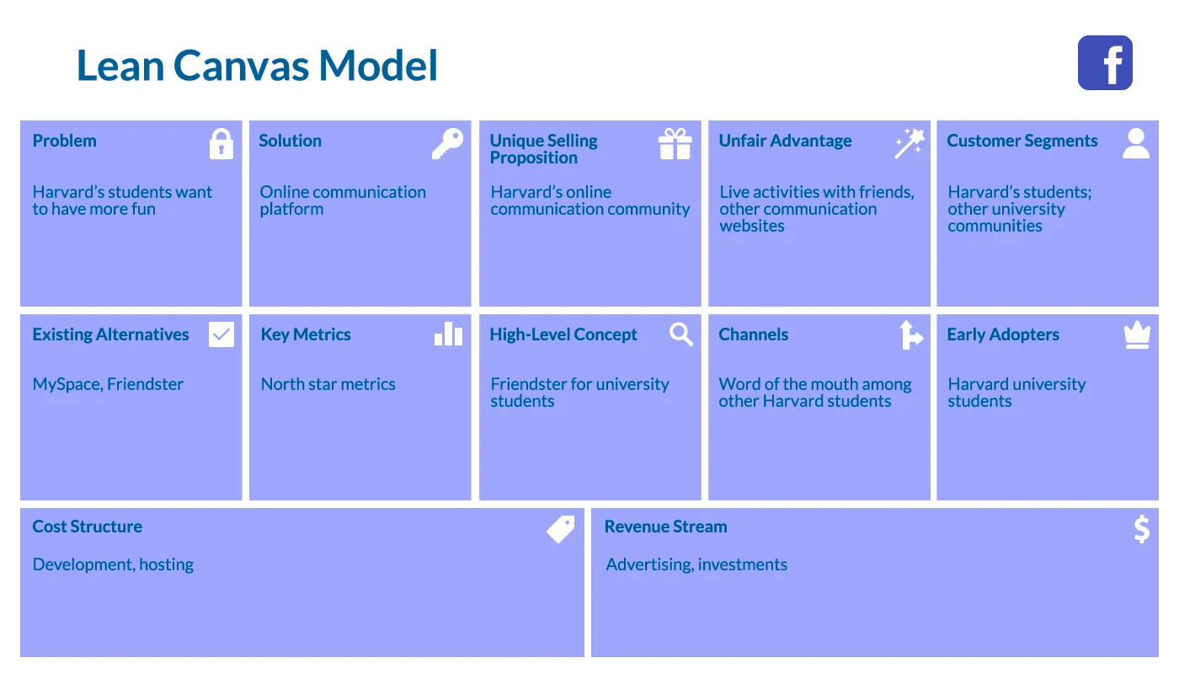

Data Gathering:-

Gather All Data supporting the Problem statement.

